 | EUROPEAN COMMISSION  DIRECTORATE-GENERAL  INFORMATICS  Information Systems Directorate

European Commission
UC0180 - e-TrustEx Admin Console - Search Credentials

Date: | 23/01/201725/04/2016
Version: | 21.000000
Authors: | Anamaria BATRINU
Revised by:
Approved by:
Public:
Reference Number:
TABLE OF CONTENTS
1. Use-Case Description 4
1.1. Primary Actor 4
1.2. Definitions, Acronyms and Abbreviations 5
1.3. References 5
1.4. Context Diagram 5
2. Flow of events 5
2.1. Basic Search Flow 6
2.1.1. User selects the Search Credentials action 6
2.1.2. System displays the "Search Credentials" page 6
2.1.3. User enters the search criteria 6
2.1.4. The System searches the Credentials 6
2.1.5. System displays the Credentials found 6
2.1.6. User views the result list 6
2.1.7. The basic search flow ends. 7
2.2. Alternative Flows 7
2.2.1. AS1: at step 2.1.4, no credential found for the specified criteria 7
2.2.2. AS2: at steps 2.1.3, or 2.1.6 User chooses Cancel option 7
2.3. Exceptional Flows 7
2.3.1. E1: at step 2.1.4, Business Rules are not verified 7
2.3.2. E2: at any step, a technical error occurs 7
3. Special Requirements 7
3.1. Interface(s) with other Systems 7
3.2. Security Requirements 7
3.3. Other Special Requirement 7
4. Preconditions 7
5. Post conditions 7
6. Additional Information 8
6.1. Includes 8
6.2. Extends 8
7. Mock-up screens 8
7.1. Search Proxy Credentials mock-up 8
7.2. Search Authentication Credentials mock-ups 9
7.2.1. JMS Endpoint Credentials 9
7.2.2. Webservice Endpoint Credentials 10
7.2.3. AMQP Endpoint Credentials 11

Document History

Version | Date | Comment | Modified Pages
1.000 | 25/04/2016 | First version - JIRA CIPADMIN-499 (User shall be able to search for credentials in specific contexts) | All
1.001 | 19/08/2016 | Introduced credentials type criteria.
1.002 | 26/10/2016 | JIRA ETRUSTEX-1392
1.003 | 24/11/2016 | JIRA ETRUSTEX-1901
1.004 | 01/12/2016 | JIRA ETRUSTEX-1585
2.000 | 23/01/2017 | ETRUSTEX-1937: Reorganizing CIPAdmin user roles

Use-Case Description
This use case describes the search of credentials which is needed in specific contexts.
The "Search Credentials" Use Case is invoked by other use cases depending on specific business needs.
In the remainder of the document the CIPAdmin application will be referred to as the System.

Primary Actor
A humain user having General Administrator or Support role can access the Search Credentials feature via specific modules of CIPAdmin interface.

Definitions, Acronyms and Abbreviations
Acronym, Abbreviation or Definition | Explanation
CIPA | Common Infrastructure for Public Administrations
CIPADMIN | CIPA AdminConsole
ADM | A user having General Administrator role. The General Administrator is the Administrator of the CIPAdmin application.
CBO | A user having Central Business Owner role. The Central Business Owner is responsible for the organization and operation of a business domain and uses CIPA in his business context.
UC(s) | Use Case(s)

References
Ref. | Reference | Title / description | Version | Date
[R1]

Context Diagram
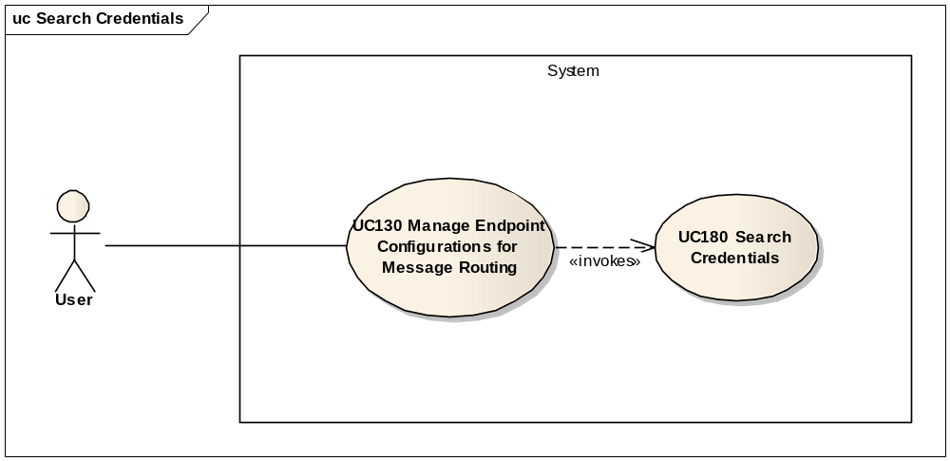

Flow of events
The conventions described in User Interface Generic Conventions document must be applied.

Basic Search Flow

User selects the Search Credentials action
User selects the Search Credentials option from any of the modules providing it. This feature is not available directly form the application menu.

System displays the "Search Credentials" page
System displays the search page as described in paragraph 7.1. "Search Credentials" page.

User enters the search criteria
- User enters the search criteria. The credentials can be searched by usernameUser activates the search button.

The System searches the Credentials
ID | Description
UC180_BR01 | The system defaults the credential type to the type provided by the caller page. This is done under the hood, not displayed in the screen.
UC180_BR02 | Username must be at least 2 characters long.
UC180_BR03 | Character case is ignored.
UC180_BR04 | Leading and trailing spaces are ignored.
UC180_BR05 | Field value can contain a partial match.
UC180_BR06 | For CBO user, the CBO's The user's selected business domain is also used to filter on the credentials associated to endpoints pertaining to it.
The system searches the credentials that satisfy all the entered criteria.

System displays the Credentials found
The system displays the list of Credentials coresponding to the search criteria, showing the following information:
  - Username
  - Depending on the type of credentials and the destination:
    - Either Proxy host and port: for Proxy type, the proxy host and port will be displayed following the pattern "proxy_host" + ":" + "proxy_port" (see 7.1 Search Proxy Credentials mock-up)
    - Either Provider URL and Destination Queue for JMS type (7.2.1 JMS Endpoint Credentials)
    - Either Webservice URL for WS type representing (7.2.2 Webservice Endpoint Credentials)
    - Either Provider URL for AMQP type (7.2.3 AMQP Endpoint Credentials)

User views the result list
- User can select a credential in the list by clicking on its corresponding line. The credential information shall be passed to the calling module.
- User can launch a new search

The basic search flow ends.

Alternative Flows

AS1: at step 2.1.4, no credential found for the specified criteria
- The system notifies the user that no credential has been found
- Alternate flow ends and basic search flow restarts at 2.1.3

AS2: at steps 2.1.3, or 2.1.6 User chooses Cancel option
- System disregards all information provided by User
- System closes the page and returns to the calling module

Exceptional Flows

E1: at step 2.1.4, Business Rules are not verified
- System logs the error
- The system highlights the field(s) in error
- The System displays the error messages.
- Flow restarts at 2.1.3.

E2: at any step, a technical error occurs
- System logs the error
- The system informs the user about the error.
- Use case ends.

Special Requirements

Interface(s) with other Systems

Security Requirements

Other Special Requirement

Preconditions
- User must be registered user of CIPAdmin tool
- User must be logged in & successfully authenticated on the e-TrustEx Admin Console

Post conditions
- [Success] Following the main flow, the Credentials have been found and passed to the calling module. Following first alternate flow, the user has been informed that the desired credentials do not exist.
- [Failure] The System logs the failure reason and the context, the use case is aborted and the primary actor has been notified of the reasons.

Additional Information

Includes
- For authentication and operation authorization: UC 0100 - eTrustEx Admin Console - Authenticate and Authorise User
- For logging: UC 0110 - eTrustEx Admin Console - Log CIPAdmin User Actions

Extends

Mock-up screens

Search Proxy Credentials mock-up
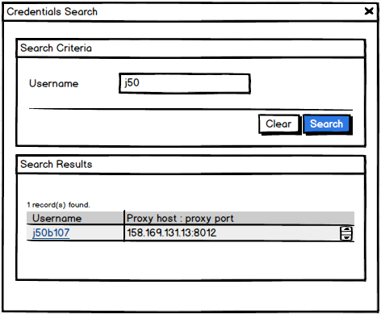
Figure 1- PROXY Credentials Search
- Search Criteria section
  - Search fields:
    - username
  - Clear and Search options are present.
- Search Results section
  - The number of results found is shown to the user
  - The results list shows for each credentials found:
    - The username and
    - The proxy host and port
  - The results list is ordered by username in ascendant alphabetical order and ignoring case
  - The username in the results list is interactive, and clicking on it will select the username and return it to the caller module

Search Authentication Credentials mock-ups

JMS Endpoint Credentials
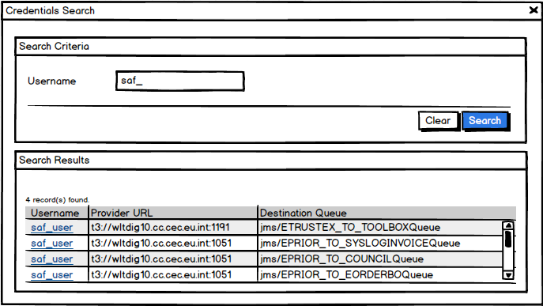
Figure 2 - Authentication Credentials (JMS endpoint)
- See point (1) from 7.1 Search Proxy Credentials mock-up
- Search Results section
  - See point (2) subpoint (a) from 7.1 Search Proxy Credentials mock-up
  - The results list shows for each credentials found:
    - The username
    - The provider URL and
    - The JMS destination queue
  - See point (2) subpoints (c) and (d) from 7.1 Search Proxy Credentials mock-up

Webservice Endpoint Credentials
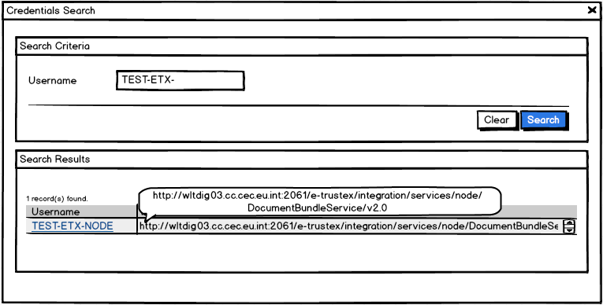
Figure 3 - Authentication Credentials (Webservice endpoint)

- See point (1) from 7.1 Search Proxy Credentials mock-up
- Search Results section
  - See point (2) subpoint (a) from 7.1 Search Proxy Credentials mock-up
  - The results list shows for each credentials found:
    - The username and
    - The webservice URL
  - See point (2) subpoints (c) and (d) from 7.1 Search Proxy Credentials mock-up

AMQP Endpoint Credentials
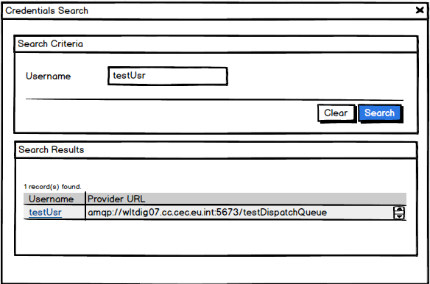
Figure 4 - Authentication Crendentials (AMQP Endpoint)

- See point (1) from 7.1 Search Proxy Credentials mock-up
- Search Results section
  - See point (2) subpoint (a) from 7.1 Search Proxy Credentials mock-up
  - The results list shows for each credentials found:
    - The username and
    - The AMQP provider URL
  - See point (2) subpoints (c) and (d) from 7.1 Search Proxy Credentials mock-up

